

AI Project Report(INT404)

Team:-
R.NO.| Name |Reg.No.
A16 |Abu Israr |11802022
A02 |Pritam Kumar |11801987
A05 |Ritika Kumari |11802096
A03 |Shubhra Bhowmik|11801990

Simple Navigation System For LPU

Introduction:-
This project will help you to navigate from some blocks of LPU (i.e. 25,26,27,28,29,30 etc) this project is totally based on Dijkstra’s shortest path algorithm.
By the help of Tkinter and some other important resources we have made map from scratch.
It will take two entries, current and final destinations, by clicking on the enter button on the map, a possible shortest path will display.

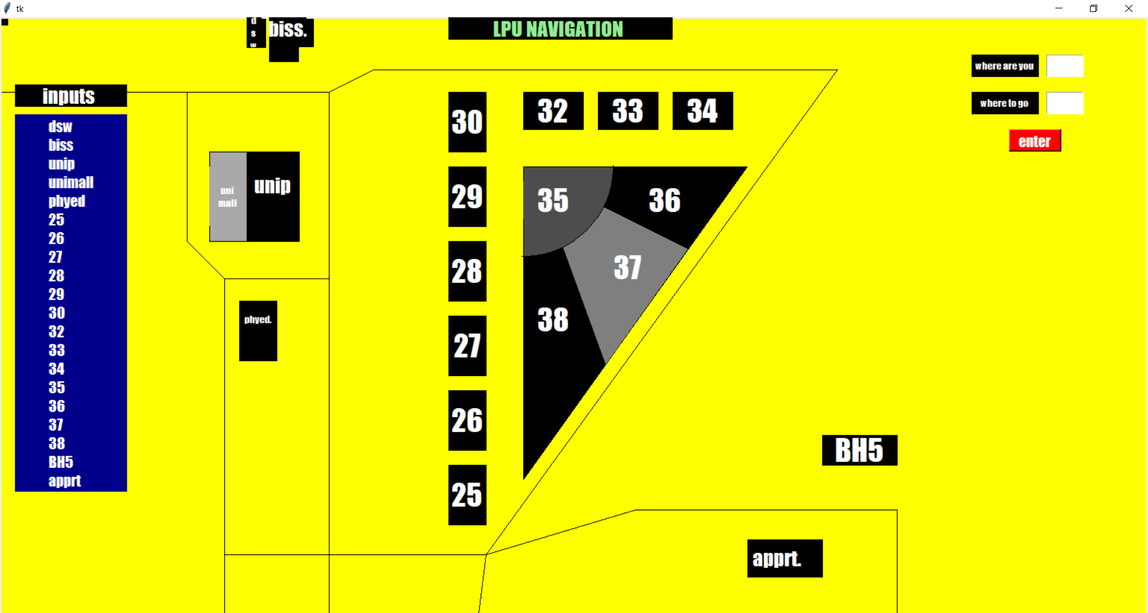
Test Cases: -
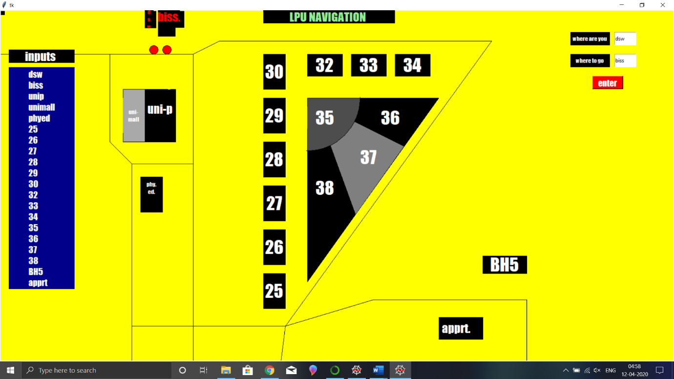
here we can see as the dsw and biss are two blocks and they are neighbours.

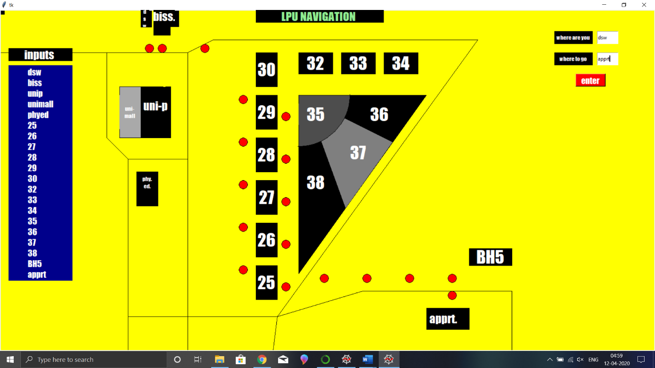
Here we are going from dsw to apprt in between blocks there are two possible ways as showed in the picture.

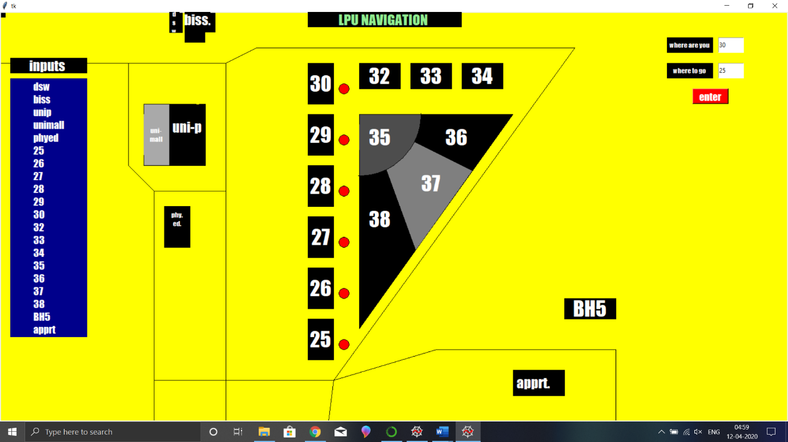
Simple path between block 30 and block 25.

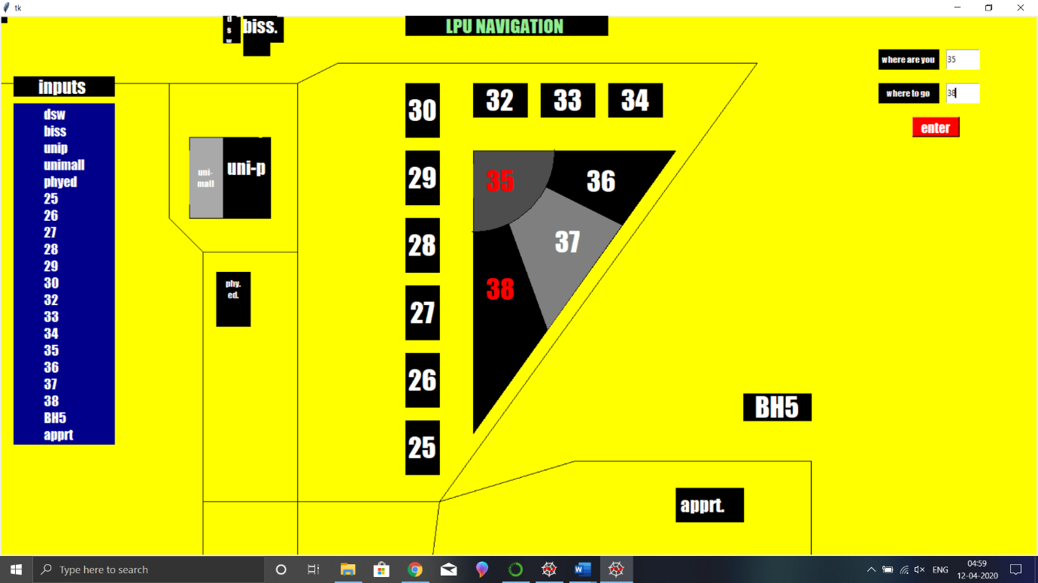
As the paths are from inside the block and there are neighbours also so simply from inside the block we can go to block 38.

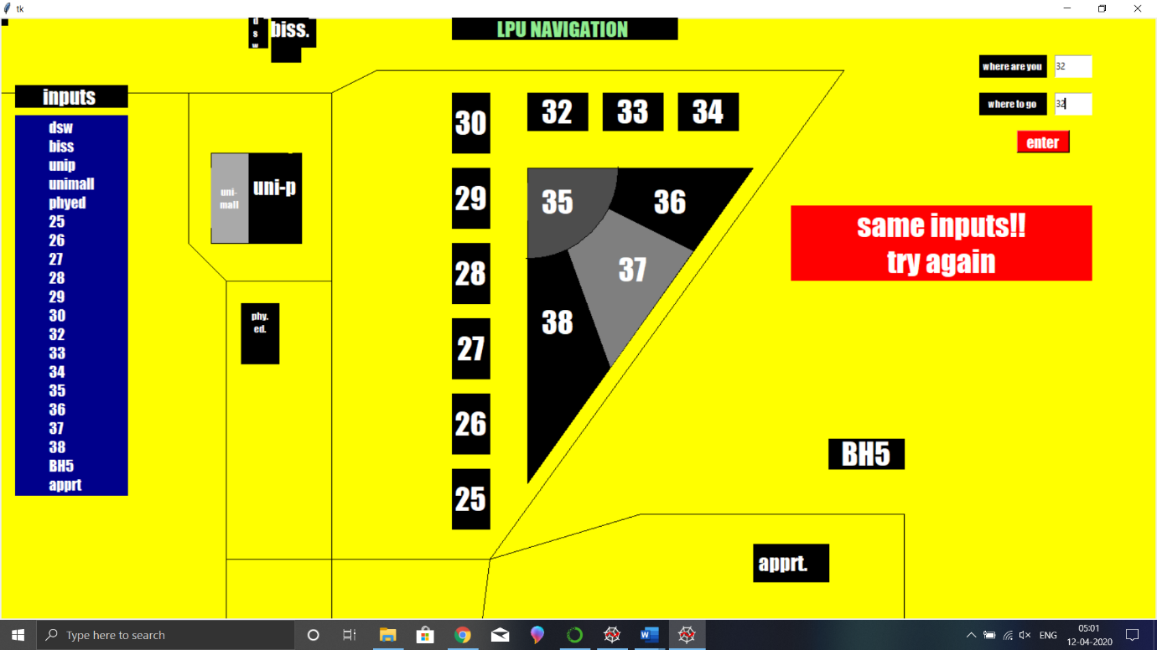
We can see as we input the same data in both fields we get an error which says same input as there is no possible way to go same place where were you standing.

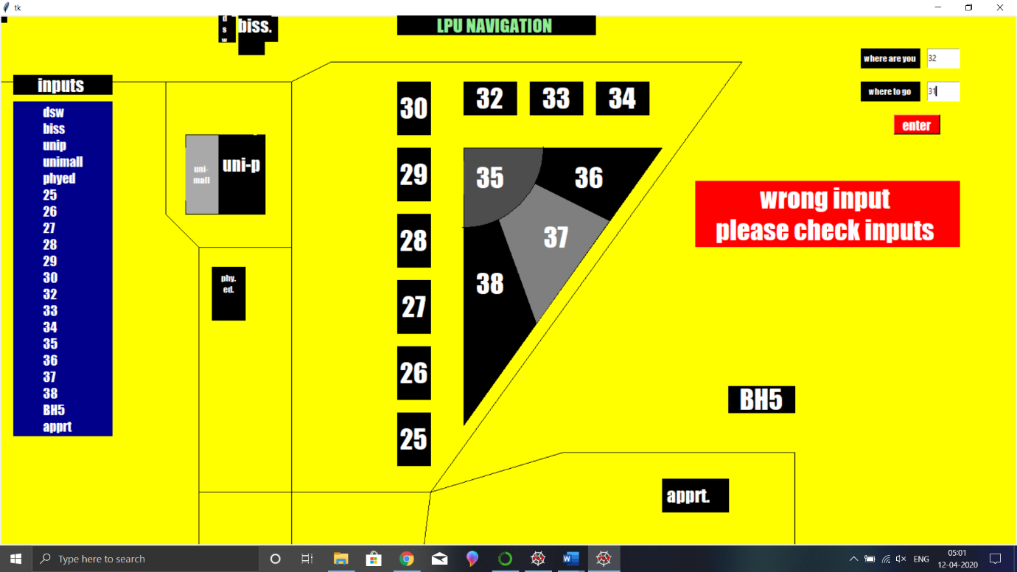
Wrong inputs will display a warning sign, “wrong input please check inputs”.
Input should be as same variable which is given in left side of the screen.

For implementing of Dijkstra algorithm ,there should be weighted graph.
Graph:-
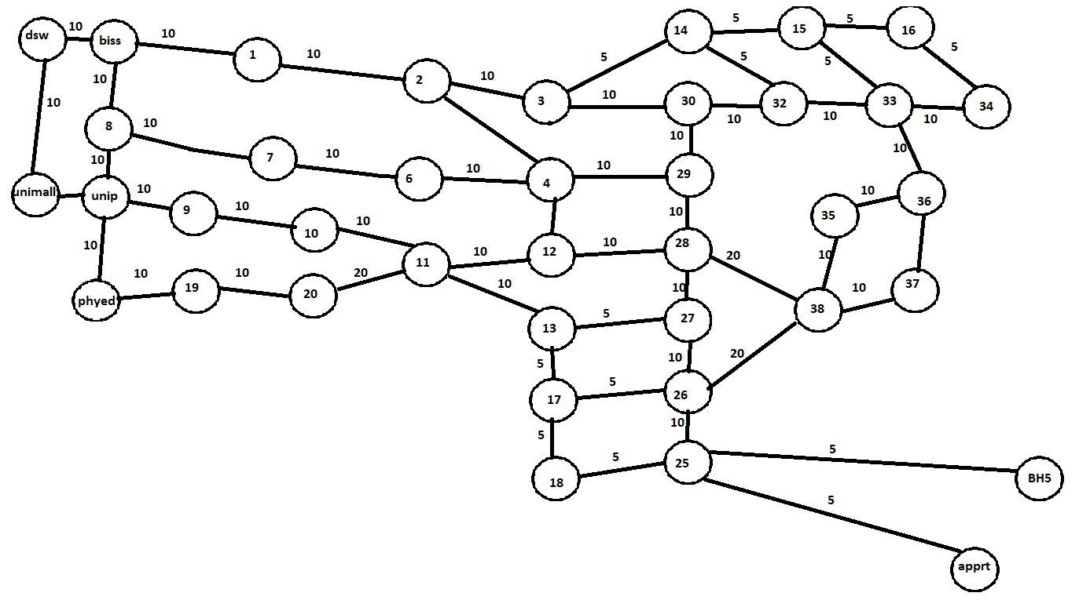

Source code:-

Link:-
# -*- coding: utf-8 -*-
"""
Created on Fri Apr 10 00:51:25 2020

@author: israr
"""

import tkinter as tk
root=tk.Tk()
q=0
canvas = tk.Canvas(root,height=800,width=100000,bg="yellow")
canvas.create_rectangle(0,0,10,10,fill="black")
label=tk.Label(root,text="LPU NAVIGATION ",font=("impact",20),bg='black',fg='lightgreen')
label.place(x=600,y=0,width=300,height=30)
canvas.create_rectangle(600,100,650,180,fill="black")#30
label30=tk.Label(root,text="30",font=("impact",30),bg='black',fg='White')
label30.place(x=600,y=100,width=50,height=80)
canvas.create_rectangle(600,200,650,280,fill="black")#29
label29=tk.Label(root,text="29",font=("impact",30),bg='black',fg='White')
label29.place(x=600,y=200,width=50,height=80)
canvas.create_rectangle(600,300,650,380,fill="black")#28
label=tk.Label(root,text="28",font=("impact",30),bg='black',fg='White')
label.place(x=600,y=300,width=50,height=80)
canvas.create_rectangle(600,400,650,480,fill="black")#27
label=tk.Label(root,text="27",font=("impact",30),bg='black',fg='White')
label.place(x=600,y=400,width=50,height=80)
canvas.create_rectangle(600,500,650,580,fill="black")#26
label=tk.Label(root,text="26",font=("impact",30),bg='black',fg='White')
label.place(x=600,y=500,width=50,height=80)
canvas.create_rectangle(600,600,650,680,fill="black")#25
label=tk.Label(root,text="25",font=("impact",30),bg='black',fg='White')
label.place(x=600,y=600,width=50,height=80)
canvas.create_rectangle(700,100,780,150,fill="black")#32
label=tk.Label(root,text="32",font=("impact",30),bg='black',fg='White')
label.place(x=700,y=100,width=80,height=50)
canvas.create_rectangle(800,100,880,150,fill="black")#33
label=tk.Label(root,text="33",font=("impact",30),bg='black',fg='White')
label.place(x=800,y=100,width=80,height=50)
canvas.create_rectangle(900,100,980,150,fill="black")#34
label=tk.Label(root,text="34",font=("impact",30),bg='black',fg='White')
label.place(x=900,y=100,width=80,height=50)
canvas.create_polygon(700,200,1000,200,700,620,fill="black")#36/38
label=tk.Label(root,text="36",font=("impact",30),bg='black',fg='White')
label.place(x=850,y=220,width=80,height=50)
label=tk.Label(root,text="38",font=("impact",30),bg='black',fg='White')
label.place(x=700,y=380,width=80,height=50)
canvas.create_polygon(800,250,750,300,810,465,920,310,fill="grey50")#37
label=tk.Label(root,text="37",font=("impact",30),bg='grey50',fg='White')
label.place(x=800,y=310,width=80,height=50)
canvas.create_arc(580,80,820,320,extent=-90,fill="grey30")#35
label=tk.Label(root,text="35",font=("impact",30),bg='grey30',fg='White')
label.place(x=700,y=220,width=80,height=50)
#canvas.create_rectangle(420,60,1129,85,fill="orange")#r1
#canvas.create_polygon(660,680,665,720,1130,85,1110,60,fill="orange")#r2
canvas.create_rectangle(1100,560,1200,600,fill="black")#BH5
label=tk.Label(root,text="BH5",font=("impact",30),bg='black',fg='White')
label.place(x=1110,y=560,width=80,height=40)
canvas.create_rectangle(1000,700,1100,750,fill="black")#aaprt.
label=tk.Label(root,text="apprt.",font=("impact",20),bg='black',fg='White')
label.place(x=1000,y=700,width=80,height=50)
canvas.create_rectangle(330,180,400,300,fill="black")#uni-p
label=tk.Label(root,text="unip",font=("impact",20),bg='black',fg='White')
label.place(x=330,y=200,width=70,height=50)
canvas.create_polygon(360,0,360,60,400,60,400,40,420,40,420,0,fill="black")#biss40
label=tk.Label(root,text="biss.",font=("impact",20),bg='black',fg='White')
label.place(x=360,y=0,width=50,height=30)
canvas.create_rectangle(330,0,355,40,fill="black")#DSW
label=tk.Label(root,text="d\ns\nw",font=("impact",10),bg="black",fg='White')
label.place(x=330,y=0,width=20,height=40)
canvas.create_rectangle(280,180,330,300,fill="darkgrey")#uni-mall
label=tk.Label(root,text="uni\nmall",font=("impact",10),bg='darkgrey',fg='white')
label.place(x=280,y=200,width=50,height=80)
canvas.create_rectangle(320,380,370,460,fill="black")#physical
label=tk.Label(root,text="phyed.",font=("impact",10),bg='black',fg='White')
label.place(x=320,y=380,width=50,height=50)
canvas.create_line(0,100,250,100,440,100,500,70,1120,70,650,720,850,660,1200,660,1200,800,1200,660,850,660,650,720,640,800,650,720,300,720,300,800,300,350,440,350,440,820,440,100,250,100,250,300,300,350)
label=tk.Label(root,text="inputs ",font=("impact",20),bg='black',fg='White')
label.place(x=20,y=90,width=150,height=30)
label=tk.Label(root,text="dsw\nbiss\nunip\nunimall\nphyed\n25\n26\n27\n28\n29\n30\n32\n33\n34\n35\n36\n37\n38\nBH5\napprt ",font=("impact",15),justify='left',bg='darkblue',fg='White')
label.place(x=20,y=130,width=150)
label=tk.Label(root,text="where are you ",font=("impact",10),bg='black',fg='White')
label.place(x=1300,y=50,width=90,height=30)

inter1=tk.Entry(root)
inter1.place(x=1400,y=50,width=50,height=30)

label=tk.Label(root,text="where to go ",font=("impact",10),bg='black',fg='White')
label.place(x=1300,y=100,width=90,height=30)
inter2=tk.Entry(root)
inter2.place(x=1400,y=100,width=50,height=30)

compute1=tk.Button(root,text="enter",font="impact",bg='red',fg='White',bd=2,command=lambda:getc(inter1.get(),inter2.get()))
compute1.place(x=1350,y=150,width=70,height=30)

################################# NINDECATE FUNTION - change color of the current and destination ############################
def nindecate(c,d):
if(c=='30' or d=='30'):
print("k")
label1=tk.Label(root,text="30",font=("impact",30),bg='black',fg='red')
label1.place(x=600,y=100,width=50,height=80)

if(c=='29' or d=='29'):
label2=tk.Label(root,text="29",font=("impact",30),bg='black',fg='red')
label2.place(x=600,y=200,width=50,height=80)
if(c=='28' or d=='28'):
label2=tk.Label(root,text="28",font=("impact",30),bg='black',fg='red')
label2.place(x=600,y=300,width=50,height=80)
if(c=='27' or d=='27'):
label3=tk.Label(root,text="27",font=("impact",30),bg='black',fg='red')
label3.place(x=600,y=400,width=50,height=80)
if(c=='26' or d=='26'):
label4=tk.Label(root,text="26",font=("impact",30),bg='black',fg='red')
label4.place(x=600,y=500,width=50,height=80)
if(c=='25' or d=='25'):
label5=tk.Label(root,text="25",font=("impact",30),bg='black',fg='red')
label5.place(x=600,y=600,width=50,height=80)
if(c=='32' or d=='32'):
label6=tk.Label(root,text="32",font=("impact",30),bg='black',fg='red')
label6.place(x=700,y=100,width=80,height=50)
if(c=='33' or d=='33'):
label7=tk.Label(root,text="33",font=("impact",30),bg='black',fg='red')
label7.place(x=800,y=100,width=80,height=50)
if(c=='34' or d=='34'):
label8=tk.Label(root,text="34",font=("impact",30),bg='black',fg='red')
label8.place(x=900,y=100,width=80,height=50)
if(c=='35' or d=='35'):
label9=tk.Label(root,text="35",font=("impact",30),bg='grey30',fg='red')
label9.place(x=700,y=220,width=80,height=50)
if(c=='36' or d=='36'):
label10=tk.Label(root,text="36",font=("impact",30),bg='black',fg='red')
label10.place(x=850,y=220,width=80,height=50)
if(c=='37' or d=='37'):
label11=tk.Label(root,text="37",font=("impact",30),bg='grey50',fg='red')
label11.place(x=800,y=310,width=80,height=50)
if(c=='38' or d=='38'):
label12=tk.Label(root,text="38",font=("impact",30),bg='black',fg='red')
label12.place(x=700,y=380,width=80,height=50)
if(c=='biss' or d=='biss'):
label13=tk.Label(root,text="biss.",font=("impact",20),bg='black',fg='red')
label13.place(x=360,y=0,width=50,height=30)
b=canvas.create_oval(370,80,390,100,fill="red")
if(c=='dsw' or d=='dsw'):
label14=tk.Label(root,text="d\ns\nw",font=("impact",10),bg="black",fg='red')
label14.place(x=330,y=0,width=20,height=40)
b=canvas.create_oval(340,80,360,100,fill="red")

if(c=='unip' or d=='unip'):
label15=tk.Label(root,text="uni-p",font=("impact",20),bg='black',fg='red')
label15.place(x=330,y=200,width=70,height=50)
if(c=='unimall' or d=='unimall'):
label16=tk.Label(root,text="uni-\nmall",font=("impact",10),bg='darkgrey',fg='red')
label16.place(x=280,y=200,width=50,height=80)
if(c=='phyed' or d=='phyed'):
label17=tk.Label(root,text="phy.\ned.",font=("impact",10),bg='black',fg='red')
label17.place(x=320,y=380,width=50,height=50)
b=canvas.create_oval(340,340,360,360,fill="red")
if(c=='apprt' or d=='apprt'):
label=tk.Label(root,text="apprt.",font=("impact",20),bg='black',fg='red')
label.place(x=1000,y=700,width=80,height=50)
if(c=='BH5' or d=='BH5'):
label18=tk.Label(root,text="BH5",font=("impact",30),bg='black',fg='red')
label18.place(x=1110,y=560,width=80,height=40)
b1=canvas.create_oval(1050,660,1070,680,fill="red")
b1=canvas.create_oval(1050,620,1070,640,fill="red")
b1=canvas.create_oval(1150,620,1170,640,fill="red")

######################################### NEB FUNTION - it store neibours of all locations , and return an array of the neibours of the current location ##################
def neb(c):
print("3")
#neighbours
n30= ['29','32']
if (c=='30'):
return (n30)
n29= ['28','30']
if (c=='29'):
return (n29)
n32= ['30','33']
if (c=='32'):
return (n32)
n33= ['32','34','35','36']
if (c=='33'):
return (n33)
n34= ['33']
if (c=='34'):
return (n34)
n35= ['36','38']
if (c=='35'):
return (n35)
n36= ['35','37']
if (c=='36'):
return (n36)
n37= ['36','38']
if (c=='37'):
return (n37)
n38= ['28','35','37']
if (c=='38'):
return (n38)
n25= ['26']
if (c=='25'):
return (n25)
n26= ['25','27','38']
if (c=='26'):
return (n26)
n27= ['26','28']
if (c=='27'):
return (n27)
n28= ['27','29','38']
if (c=='28'):
return (n28)
nbiss= ['dsw','unimall','unip']
if (c=='biss'):
return (nbiss)
ndsw= ['biss','unimall','unip']
if (c=='dsw'):
return (ndsw)
nunip= ['unimall','dsw','biss','phyed']
if (c=='unip'):
return (nunip)
nunimall= ['unip','dsw','biss','phyed']
if (c=='unimall'):
return (nunimall)
uphyed=['unimall','unip']
if (c=='phyed'):
return (uphyed)
uBH4=['apprt']
uapprt=['BH5']
if(c=='BH5'):
return (uBH4)
if(c=='apprt'):
return (uapprt)
else:
return 'x'

from collections import defaultdict
############################## GRAPH CLASS - to make and store data(distance of each nodes) and the dijsktra algo #########################
class Graph():
def __init__(self):
"""
self.edges is a dict of all possible next nodes
e.g. {'X': ['A', 'B', 'C', 'E'], ...}
self.weights has all the weights between two nodes,
with the two nodes as a tuple as the key
e.g. {('X', 'A'): 7, ('X', 'B'): 2, ...}
"""
self.edges = defaultdict(list)
self.weights = {}

def add_edge(self, from_node, to_node, weight):
# Note: assumes edges are bi-directional
self.edges[from_node].append(to_node)
self.edges[to_node].append(from_node)
self.weights[(from_node, to_node)] = weight
self.weights[(to_node, from_node)] = weight

graph=Graph()
edges = [
('34', '33', 10), ('33', '32', 10), ('33', '36', 10), ('33', '35', 10),('36', '35', 10), ('36', '37', 10), ('35', '38', 10), ('38', '37', 10), ('38', '28', 20), ('38', '27', 20), ('25', '26', 20), ('26', '27', 10), ('27', '28', 10), ('28', '29', 10), ('29', '30', 10), ('30', '32', 10), ('30','3',10), ('3','2',10), ('2','1',10), ('1','biss',10), ('29','4',10), ('4','2',10), ('34','16',5), ('16','15',5), ('15','33',2), ('15','14',5), ('14','32',1), ('14','3',5), ('6','4',10), ('29','4',10), ('7','6',10), ('7','biss',20), ('7','8',10), ('unip','8',10), ('28','12',10), ('12','4',1), ('12','11',10), ('11','7',10), ('11','10',10), ('10','9',10), ('9','unip',10), ('13','12',10), ('13','27',5), ('17','13',5), ('17','26',5), ('17','18',5), ('18','25',5), ('biss','8',10), ('biss','dsw',10), ('unip','unimall',10), ('unip','phyed',10), ('unimall','dsw',10),('BH5','25',10),('25','apprt',10), ('12','20',20), ('20','19',10), ('19','phyed',10) ]
for edge in edges:
graph.add_edge(*edge)

############################# DIJSKTRA FUNTION- it take the detale of graph , current and final destination to calculate shortest distance and return the path ##############

def dijsktra(graph, initial, end):
# shortest paths is a dict of nodes
# whose value is a tuple of (previous node, weight)
shortest_paths = {initial: (None, 0)}
current_node = initial
visited = set()

while current_node != end:
visited.add(current_node)
destinations = graph.edges[current_node]
weight_to_current_node = shortest_paths[current_node][1]

for next_node in destinations:
weight = graph.weights[(current_node, next_node)] + weight_to_current_node
if next_node not in shortest_paths:
shortest_paths[next_node] = (current_node, weight)
else:
current_shortest_weight = shortest_paths[next_node][1]
if current_shortest_weight > weight:
shortest_paths[next_node] = (current_node, weight)

next_destinations = {node: shortest_paths[node] for node in shortest_paths if node not in visited}
if not next_destinations:
return "N"
# next node is the destination with the lowest weight
current_node = min(next_destinations, key=lambda k: next_destinations[k][1])

# Work back through destinations in shortest path
path = []
while current_node is not None:
path.append(current_node)
next_node = shortest_paths[current_node][0]
current_node = next_node
# Reverse path
path = path[::-1]
return path
###################### CHECK FUNTION - it check ir the final and current are neibour if yes then nindecate funtion is called and
############## if not then dijsktra funtion is called an fron the path it indecates the path ################
def check(c,d):

x=0
y=0

if(c==d):
x=1
compute=tk.Label(root,text="same inputs!!\ntry again",font=("impact",30),bg='red',fg='White')
compute.place(x=1050,y=250,width=400,height=100)
a=neb(c)
for i in a:
print ("h",i)
if(i==d):
x=1
y=1
print("wwww")

for i in ['1','2','3','4','5','6','7','8','9','10','11','12','13','14','15','16','17','18','19','20']:

if(i==c or i==d):

print("thisss")
compute=tk.Label(root,text="wrong input\n""please check inputs",font=("impact",30),bg='red',fg='White')
compute.place(x=1050,y=250,width=400,height=100)
x=1
if(x==1):
if(y==1):
print ("x=1")
nindecate(c,d)
else:

print ("x=o")

p=dijsktra(graph,c,d)
if (p=="N"):
print("that")
compute=tk.Label(root,text="wrong input \n""please check inputs ",font=("impact",30),bg='red',fg='White')
compute.place(x=1050,y=250,width=400,height=100)

else:

for i in p:
print(i)
if (i=='34' or i=='16'):
a1=canvas.create_oval(920,160,940,180,fill="red")
if (i=='33' or i=='15'):
a2=canvas.create_oval(820,160,840,180,fill="red")
if (i=='32' or i=='14'):
a3=canvas.create_oval(720,160,740,180,fill="red")
if (i=='30' or i=='3'):
a4=canvas.create_oval(660,140,680,160,fill="red")
if (i=='phyed'):
a32=canvas.create_oval(340,340,360,360,fill="red")
if (i=='29' or i=='4'):
a5=canvas.create_oval(660,240,680,260,fill="red")
if (i=='28' or i=='12'):
a6=canvas.create_oval(660,340,680,360,fill="red")
if (i=='27' or i=='13'):
a7=canvas.create_oval(660,440,680,460,fill="red")
if (i=='26' or i=='17'):
a8=canvas.create_oval(660,540,680,560,fill="red")
if (i=='25' or i=='18'):
a9=canvas.create_oval(660,640,680,660,fill="red")
if (i=='38'):
a10=canvas.create_oval(670,400,690,420,fill="red")
if (i=='35'):
a10=canvas.create_oval(670,300,690,320,fill="red")
a11=canvas.create_oval(670,180,690,200,fill="red")
if (i=='36'):
a12=canvas.create_oval(900,170,920,190,fill="red")
if (i=='biss'):
b=canvas.create_oval(370,80,390,100,fill="red")
if (i=='dsw'):
b=canvas.create_oval(340,80,360,100,fill="red")
if(i=='BH5'):
a33=canvas.create_oval(750,620,770,640,fill="red")
a33=canvas.create_oval(850,620,870,640,fill="red")
a33=canvas.create_oval(950,620,970,640,fill="red")
a33=canvas.create_oval(1050,620,1070,640,fill="red")
a33=canvas.create_oval(1150,620,1170,640,fill="red")
if(i=='apprt'):
a34=canvas.create_oval(750,620,770,640,fill="red")
a34=canvas.create_oval(850,620,870,640,fill="red")
a34=canvas.create_oval(950,620,970,640,fill="red")
a34=canvas.create_oval(1050,620,1070,640,fill="red")
a34=canvas.create_oval(1050,660,1070,680,fill="red")
if ( ((c=='biss' or c== 'dsw' or c=='unip' or c=='unimall' or c=='phyed' ) and (d=='30'or d=='32'or d=='33'or d=='34'or d=='35'or d=='36'or d=='37'or d=='38'or d=='25'or d=='26'or d=='27'or d=='28'or d=='29' or d=='BH5' or d=='apprt'))or((d=='biss' or d== 'dsw' or d=='unip' or d=='unimall' or d=='phyed' ) and (c=='30'or c=='32'or c=='33'or c=='34'or c=='35'or c=='36'or c=='37'or c=='38'or c=='25'or c=='26'or c=='27'or c=='28'or c=='29'or c=='BH5' or c=='apprt'))):
print ("i"+i)
if (i=='1'):
a14=canvas.create_oval(370,80,390,100,fill="red")
if (i=='2'):
a15=canvas.create_oval(470,80,490,100,fill="red")
if (i=='3'):
a16=canvas.create_oval(560,80,580,100,fill="red")
if (i=='4'):
a17=canvas.create_oval(560,200,580,220,fill="red")
if (i=='5'):
a18=canvas.create_oval(560,300,580,320,fill="red")
if (i=='6'):
a19=canvas.create_oval(480,190,500,210,fill="red")
if (i=='7'):
a21=canvas.create_oval(450,167,430,187,fill="red")
if (i=='8'):
a22=canvas.create_oval(375,160,395,180,fill="red")
if (i=='9'):
a23=canvas.create_oval(375,180,395,200,fill="red")
if(i=='10'):
a24=canvas.create_oval(450,250,470,270,fill="red")
if(i=='11'):
a25=canvas.create_oval(500,260,520,280,fill="red")
if(i=='12'):
a26=canvas.create_oval(560,300,580,320,fill="red")
if(i=='13'):
a27=canvas.create_oval(560,400,580,420,fill="red")
if(i=='14'):
a30=canvas.create_oval(660,60,680,80,fill="red")
if(i=='15'):
a31=canvas.create_oval(780,60,800,80,fill="red")
if(i=='16'):
a32=canvas.create_oval(880,60,900,80,fill="red")
#if (i=='37'):
if(i=='17'):
a28=canvas.create_oval(560,500,580,520,fill="red")# a13=canvas.create_oval(920,160,940,180,fill="red")
if(i=='18'):
a29=canvas.create_oval(560,600,580,620,fill="red")
if(i=='19'):
a30=canvas.create_oval(440,320,460,340,fill="red")
if(i=='20'):
a31=canvas.create_oval(500,320,520,340,fill="red")
if (i=='phyed'):
a32=canvas.create_oval(340,340,360,360,fill="red")

############################# GETC FUNTION - when enter button is pressed in the canvas is funtion is called
def getc(c,d):
clear()
print("1")
compute=tk.Label(root,text="",font=("impact",30),bg='yellow',fg='White')
compute.place(x=1050,y=250,width=400,height=100)
check(c,d)
def clear():

label1=tk.Label(root,text="30",font=("impact",30),bg='black',fg='white')
label1.place(x=600,y=100,width=50,height=80)

label2=tk.Label(root,text="29",font=("impact",30),bg='black',fg='white')
label2.place(x=600,y=200,width=50,height=80)

label2=tk.Label(root,text="28",font=("impact",30),bg='black',fg='white')
label2.place(x=600,y=300,width=50,height=80)

label3=tk.Label(root,text="27",font=("impact",30),bg='black',fg='white')
label3.place(x=600,y=400,width=50,height=80)

label4=tk.Label(root,text="26",font=("impact",30),bg='black',fg='white')
label4.place(x=600,y=500,width=50,height=80)

label5=tk.Label(root,text="25",font=("impact",30),bg='black',fg='white')
label5.place(x=600,y=600,width=50,height=80)

label6=tk.Label(root,text="32",font=("impact",30),bg='black',fg='white')
label6.place(x=700,y=100,width=80,height=50)

label7=tk.Label(root,text="33",font=("impact",30),bg='black',fg='white')
label7.place(x=800,y=100,width=80,height=50)

label8=tk.Label(root,text="34",font=("impact",30),bg='black',fg='white')
label8.place(x=900,y=100,width=80,height=50)

label9=tk.Label(root,text="35",font=("impact",30),bg='grey30',fg='white')
label9.place(x=700,y=220,width=80,height=50)

label10=tk.Label(root,text="36",font=("impact",30),bg='black',fg='white')
label10.place(x=850,y=220,width=80,height=50)

label11=tk.Label(root,text="37",font=("impact",30),bg='grey50',fg='white')
label11.place(x=800,y=310,width=80,height=50)

label12=tk.Label(root,text="38",font=("impact",30),bg='black',fg='white')
label12.place(x=700,y=380,width=80,height=50)

label13=tk.Label(root,text="biss.",font=("impact",20),bg='black',fg='white')
label13.place(x=360,y=0,width=50,height=30)
b=canvas.create_oval(370,80,390,100,fill="yellow",outline="yellow")

label14=tk.Label(root,text="d\ns\nw",font=("impact",10),bg="black",fg='white')
label14.place(x=330,y=0,width=20,height=40)
canvas.create_oval(340,80,360,100,fill="yellow",outline="yellow")

label15=tk.Label(root,text="uni-p",font=("impact",20),bg='black',fg='white')
label15.place(x=330,y=200,width=70,height=50)

label16=tk.Label(root,text="uni-\nmall",font=("impact",10),bg='darkgrey',fg='white')
label16.place(x=280,y=200,width=50,height=80)

label=tk.Label(root,text="apprt.",font=("impact",20),bg='black',fg='White')
label.place(x=1000,y=700,width=80,height=50)

label17=tk.Label(root,text="phy.\ned.",font=("impact",10),bg='black',fg='white')
label17.place(x=320,y=380,width=50,height=50)
b=canvas.create_oval(340,340,360,360,fill="yellow",outline="yellow")

label18=tk.Label(root,text="BH5",font=("impact",30),bg='black',fg='white')
label18.place(x=1110,y=560,width=80,height=40)
b1=canvas.create_oval(1050,660,1070,680,fill="yellow",outline="yellow")
b1=canvas.create_oval(1050,620,1070,640,fill="yellow",outline="yellow")
b1=canvas.create_oval(1150,620,1170,640,fill="yellow",outline="yellow")

a10=canvas.create_oval(670,400,690,420,fill="yellow",outline="yellow")

a1=canvas.create_oval(920,160,940,180,fill="yellow",outline="yellow")

a2=canvas.create_oval(820,160,840,180,fill="yellow",outline="yellow")

a3=canvas.create_oval(720,160,740,180,fill="yellow",outline="yellow")

a4=canvas.create_oval(660,140,680,160,fill="yellow",outline="yellow")

a32=canvas.create_oval(340,340,360,360,fill="yellow",outline="yellow")

canvas.create_oval(340,80,360,100,fill="yellow",outline="yellow")

b=canvas.create_oval(370,80,390,100,fill="yellow",outline="yellow")

a5=canvas.create_oval(660,240,680,260,fill="yellow",outline="yellow")

a6=canvas.create_oval(660,340,680,360,fill="yellow",outline="yellow")

a7=canvas.create_oval(660,440,680,460,fill="yellow",outline="yellow")

a8=canvas.create_oval(660,540,680,560,fill="yellow",outline="yellow")

a9=canvas.create_oval(660,640,680,660,fill="yellow",outline="yellow")

a10=canvas.create_oval(670,300,690,320,fill="yellow",outline="yellow")

a11=canvas.create_oval(670,180,690,200,fill="yellow",outline="yellow")

a12=canvas.create_oval(900,170,920,190,fill="yellow",outline="yellow")

a33=canvas.create_oval(750,620,770,640,fill="yellow",outline="yellow")
a33=canvas.create_oval(850,620,870,640,fill="yellow",outline="yellow")
a33=canvas.create_oval(950,620,970,640,fill="yellow",outline="yellow")
a33=canvas.create_oval(1050,620,1070,640,fill="yellow",outline="yellow")
a33=canvas.create_oval(1150,620,1170,640,fill="yellow",outline="yellow")

a34=canvas.create_oval(750,620,770,640,fill="yellow",outline="yellow")
a34=canvas.create_oval(850,620,870,640,fill="yellow",outline="yellow")
a34=canvas.create_oval(950,620,970,640,fill="yellow",outline="yellow")
a34=canvas.create_oval(1050,620,1070,640,fill="yellow",outline="yellow")
a34=canvas.create_oval(1050,660,1070,680,fill="yellow",outline="yellow")

a14=canvas.create_oval(370,90,390,110,fill="yellow",outline="yellow")

a15=canvas.create_oval(470,80,490,100,fill="yellow",outline="yellow")

a16=canvas.create_oval(560,80,580,100,fill="yellow",outline="yellow")

a17=canvas.create_oval(560,200,580,220,fill="yellow",outline="yellow")

a18=canvas.create_oval(560,300,580,320,fill="yellow",outline="yellow")
a19=canvas.create_oval(480,190,500,210,fill="yellow",outline="yellow")
a21=canvas.create_oval(450,167,430,187,fill="yellow",outline="yellow")
a22=canvas.create_oval(375,160,395,180,fill="yellow",outline="yellow")
a24=canvas.create_oval(450,250,470,270,fill="yellow",outline="yellow")
a25=canvas.create_oval(500,260,520,280,fill="yellow",outline="yellow")
a26=canvas.create_oval(560,300,580,320,fill="yellow",outline="yellow")
a27=canvas.create_oval(560,400,580,420,fill="yellow",outline="yellow")
a30=canvas.create_oval(660,60,680,80,fill="yellow",outline="yellow")
a31=canvas.create_oval(780,60,800,80,fill="yellow",outline="yellow")
a32=canvas.create_oval(880,60,900,80,fill="yellow",outline="yellow")
a28=canvas.create_oval(560,500,580,520,fill="yellow",outline="yellow")# a13=canvas.create_oval(920,160,940,180,fill="red")
a29=canvas.create_oval(560,600,580,620,fill="yellow",outline="yellow")
a30=canvas.create_oval(440,320,460,340,fill="yellow",outline="yellow")
a31=canvas.create_oval(500,320,520,340,fill="yellow",outline="yellow")
a32=canvas.create_oval(340,340,360,360,fill="yellow",outline="yellow")
canvas.create_line(0,100,250,100,440,100,500,70,1120,70,650,720,850,660,1200,660,1200,800,1200,660,850,660,650,720,640,800,650,720,300,720,300,800,300,350,440,350,440,820,440,100,250,100,250,300,300,350)
canvas.pack(fill=tk.BOTH,expand=tk.YES)
root.mainloop ()

